**Practical No 8**

**Aim**: Firing Queries on Tables.

**Solution:**

Open Application -> Microsoft SQL Server 2008 R2 -> SQL Server

Management Studio

1. Select Connect Tab -> Database Engine -> Select Server Name(local)

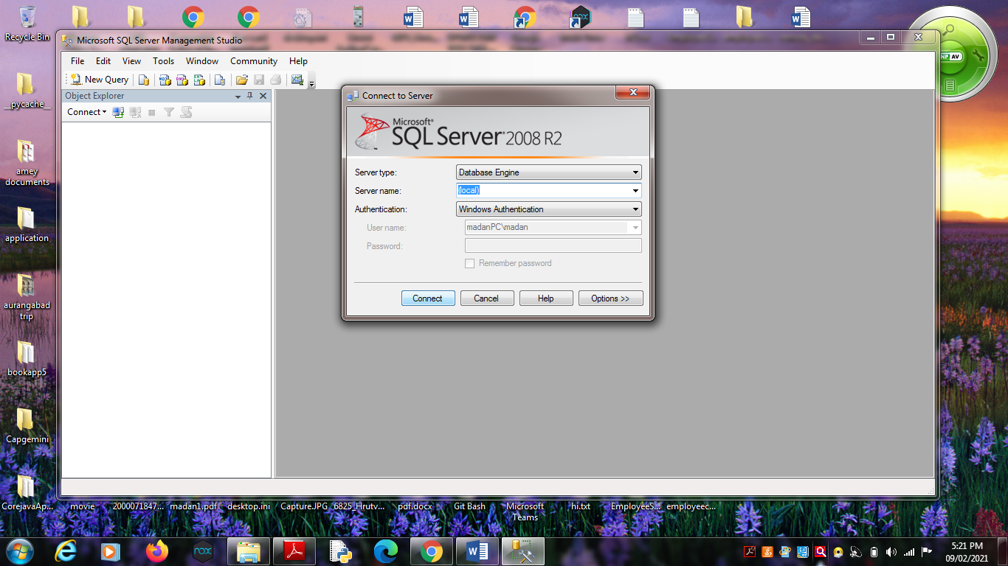

2. Expand ‘Database’ -> Expand ‘SalesProduct’ -> Expand Tables.

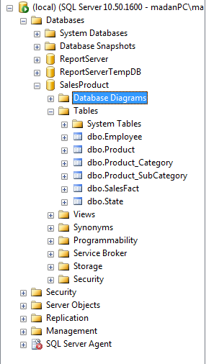

3. Fire following queries :

3.1. SELECT [Employee_ID],[Employee_Name] ,[Manager_ID]

FROM [SalesProduct].[dbo].[Employee]

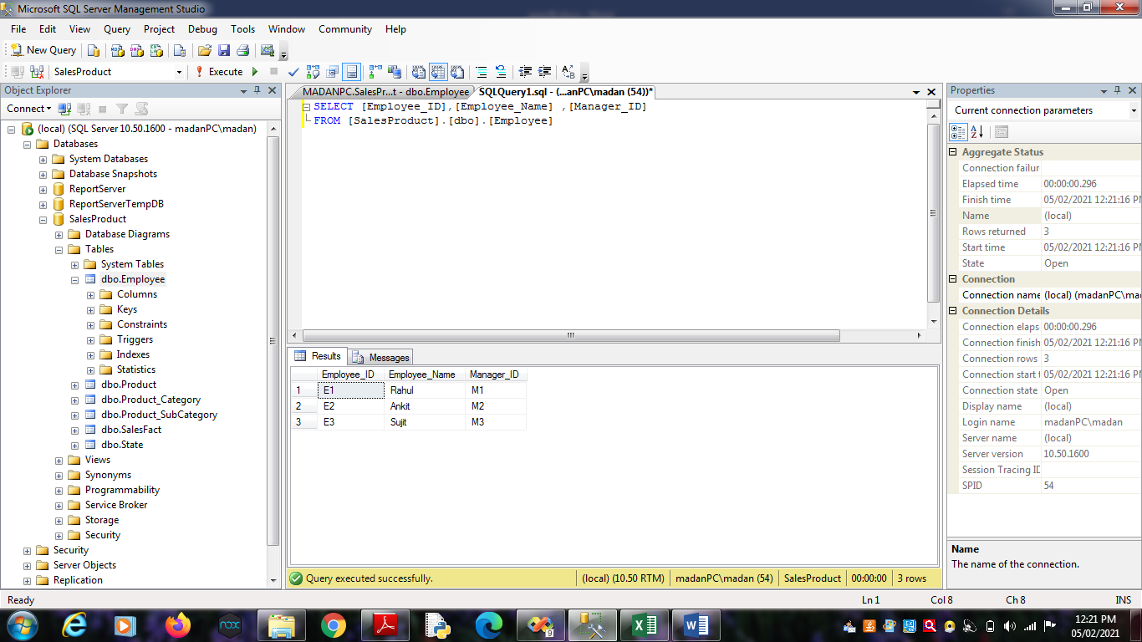

3.2 SELECT [Product_ID],[Brand_Name],[Price],[Product_Name]

,[SubCategory_ID] FROM [SalesProduct].[dbo].[Product]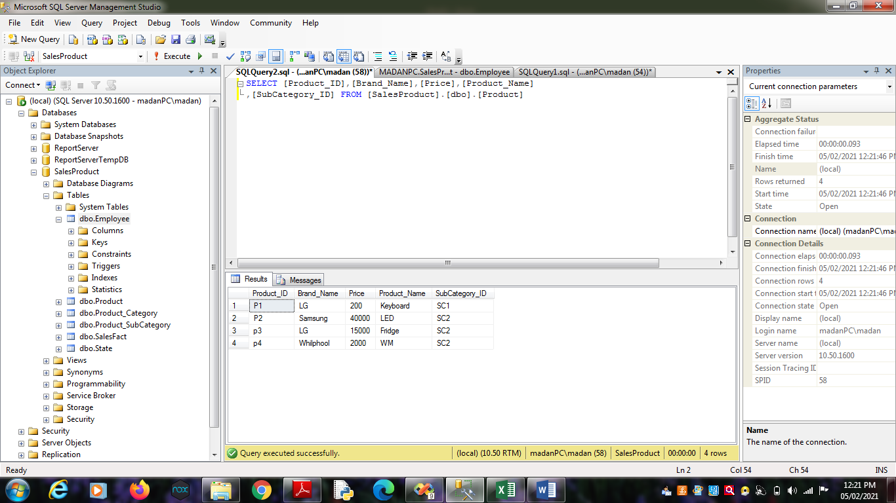

3.3. SELECT [State_ID],[Country],[Region],[State_Name]

FROM [SalesProduct].[dbo].[State]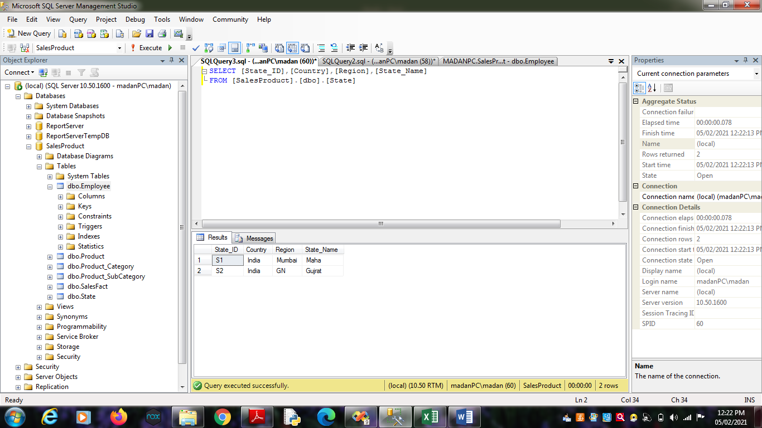

3.4. SELECT

[SubCategory_ID],[Category_Manager],[SubCategory],[Category_ID]

FROM [SalesProduct].[dbo].[Product_SubCategory]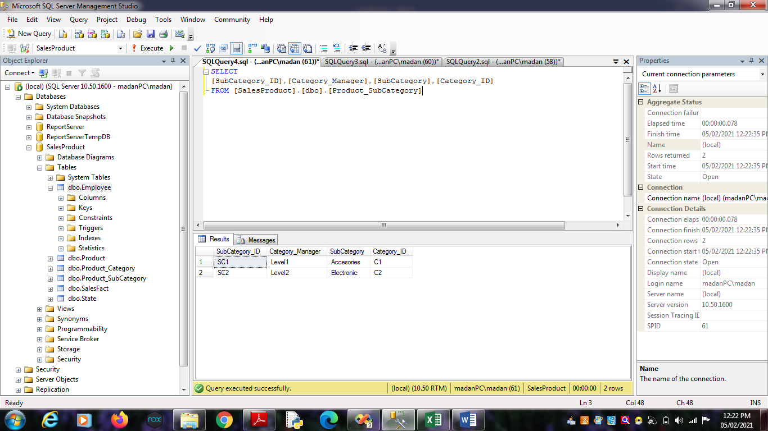

3.5. SELECT [Category_ID],[Category]

FROM [SalesProduct].[dbo].[Product_Category]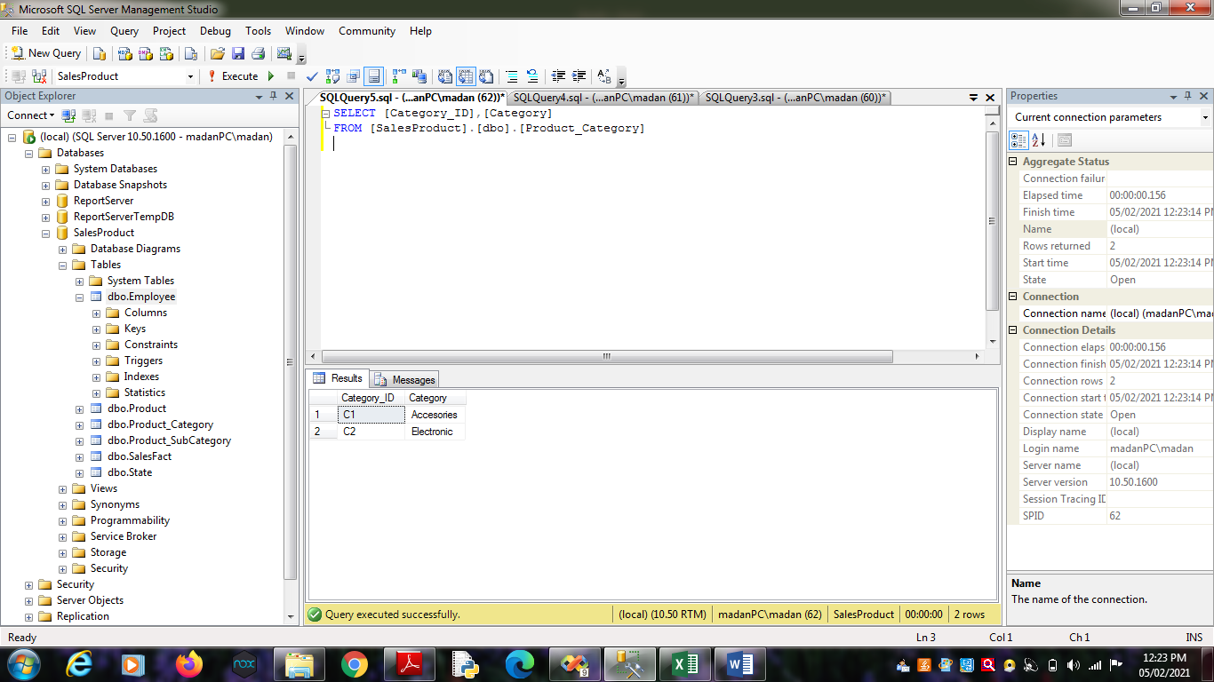

3.6. SELECT [Employee_ID],[Month],[Product_ID],[State_ID],[Sales_Dollars]

,[Sales_Units] FROM [SalesProduct].[dbo].[SalesFact]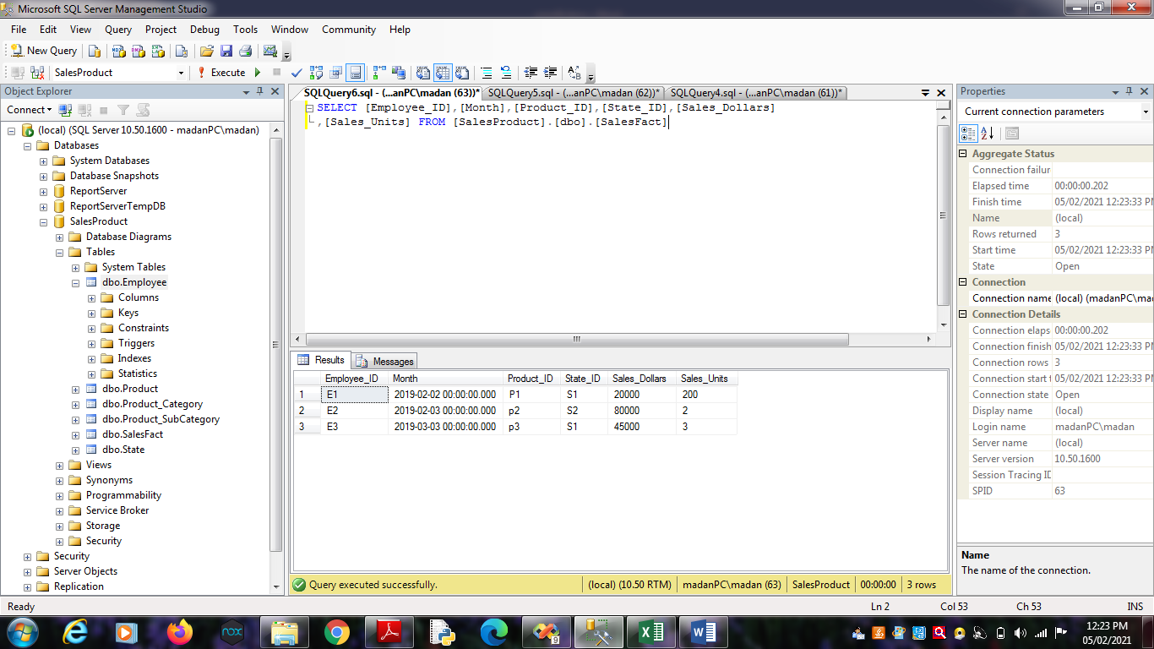

3.7. select [Employee_ID],[Sales_Dollars],[Sales_Units],

[SalesProduct].[dbo].[Product].[Product_ID],[Product_Name]

FROM [SalesProduct].[dbo].[SalesFact],[SalesProduct].[dbo].[Product]

where[SalesProduct].[dbo].[SalesFact].[Product_ID] =

[SalesProduct].[dbo].[Product].[Product_ID];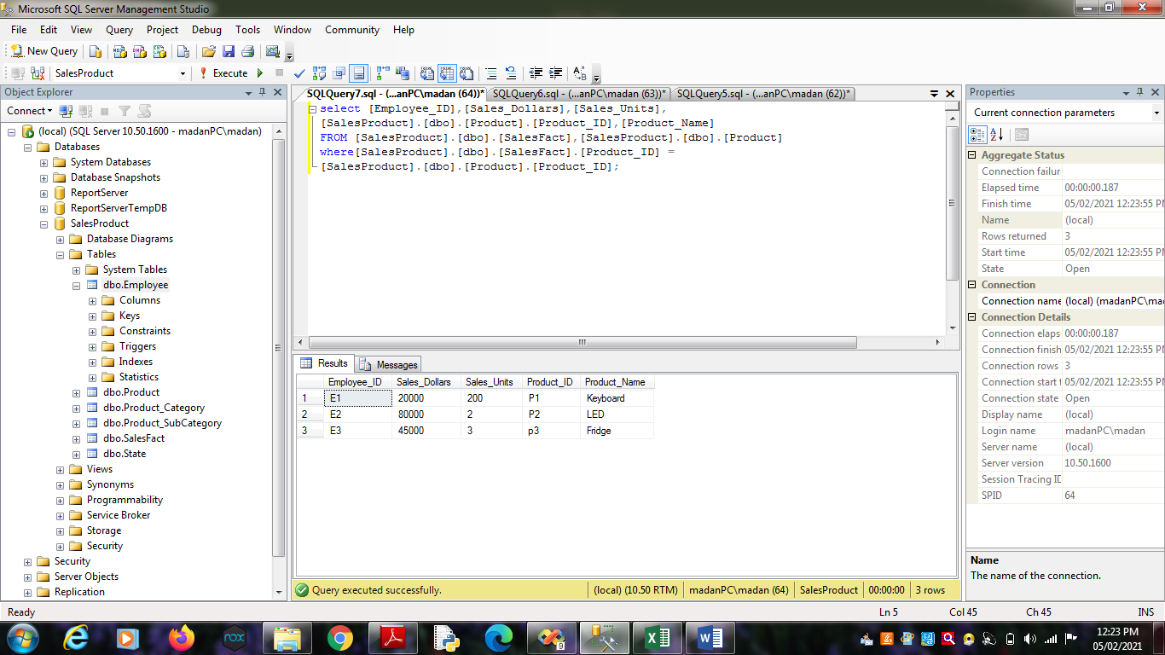

3.8. select [Employee_ID],[Sales_Dollars],[Sales_Units],

[SalesProduct].[dbo].[State].[State_ID],[State_Name]

FROM [SalesProduct].[dbo].[SalesFact],[SalesProduct].[dbo].[State]

where[SalesProduct].[dbo].[SalesFact].[State_ID] =

[SalesProduct].[dbo].[State].[State_ID];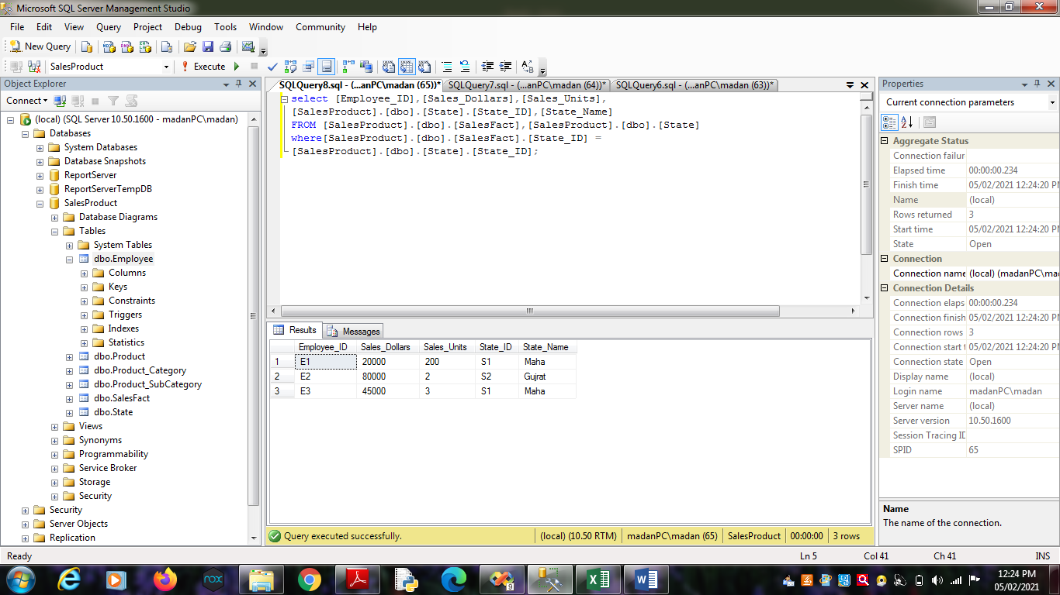

3.9. select [SalesProduct].[dbo].[Employee].[Employee_ID],[Employee_Name],

[Sales_Dollars],[Sales_Units]

FROM [SalesProduct].[dbo].[Employee] , [SalesProduct].[dbo].[SalesFact]

where [SalesProduct].[dbo].[Employee].[Employee_ID]=

[SalesProduct].[dbo].[SalesFact].[Employee_ID] ;